Contents
Context 2
Viewing a parameter 3
Within the SQL code 3
Within the Parameters folder 4
Within the Parameters textbox 5
Creating a new parameter 7
Within the SQL code 7
Within the Parameters folder 7
Within the Parameters textbox 14
Editing an existing parameter 18
Removing a parameter 18
Within the SQL code 18
Within the Parameters folder 18
Within the Parameters textbox 19
Appendix: Free-text multi-value parameters 20

Additional Guidance
Knowledge Article: not yet written
HOW TO - Manage Reports - Access Permissions within HR Reporting.docx
HOW TO - Manage Reports - Change Processes in OSM.docx
HOW TO - Manage Reports - HR Reporting Environments.docx
HOW TO - Manage Reports - Release and Deployment.docx
HOW TO - Manage Reports - Shared Data Sources.docx
HOW TO - Manage Reports - Shared Datasets.docx
HOW TO - Manage Reports - Troubleshoot Common Errors.docx
HOW TO - Manage Reports - Visual Studio Basics.docx

Context
A parameter is technically “a limit or boundary which defines the scope of a particular process or activity”. Within the context of HR Reporting, parameters are values a report user can set before running a report. These values limit the query the report sends to the database, and therefore limit the data the report will return from the database.

- Example: A report has a parameter for Department Code, which gives the user the option to select specific department codes for which they want to see results when they run the report. Let’s say they select code “AC”:

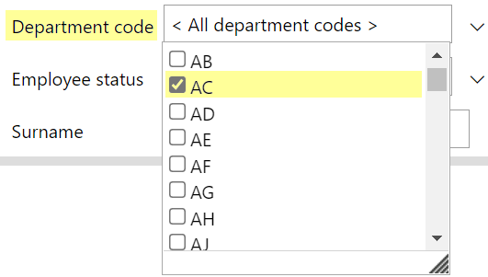

When the user clicks “View Report”, the report query will run. Because the user has selected code “AC”, the report query will only check the PeopleXD database for personnel records related to that department code. When the report is finished running, it will only display results for department code “AC”.

- Example: A report has a parameter for Personnel Number, which gives the user the option to specify a personnel record for which they want to see results when they run the report. Let’s say they enter personnel number “2367246”:

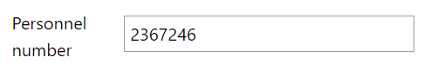

When the user clicks “View Report”, the report query will run. Because the user has specified personnel number “2367246”, the report query will only check the PeopleXD database for information related to that personnel number. When the report is finished running, it will only display results for personnel number “2367246”.

Report parameters are managed in three separate places:

- The SQL code of the report query in the .RDL file: essential
- The Parameters folder of the Report Data pane: essential
- The Parameters textbox: optional (if the parameter values should be displayed at the top of the report each time it is run)

See below for detailed guidance.

Viewing a parameter
Parameters exist within report (.RDL) files, so to view the parameters for a report, you will need to open the .RDL file whose parameters you wish to view.

Within the SQL code
To see the parameters within a report’s SQL code, go to the Report Data pane. Expand the Datasets folder and select “DataSet1” – this is where the report query SQL code is held.

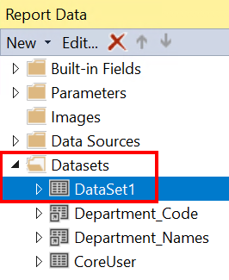

Double-click to open “DataSet1”. The Dataset Properties window will pop up. Go to the Query pane in the lower half of the window to see the SQL code for the report:

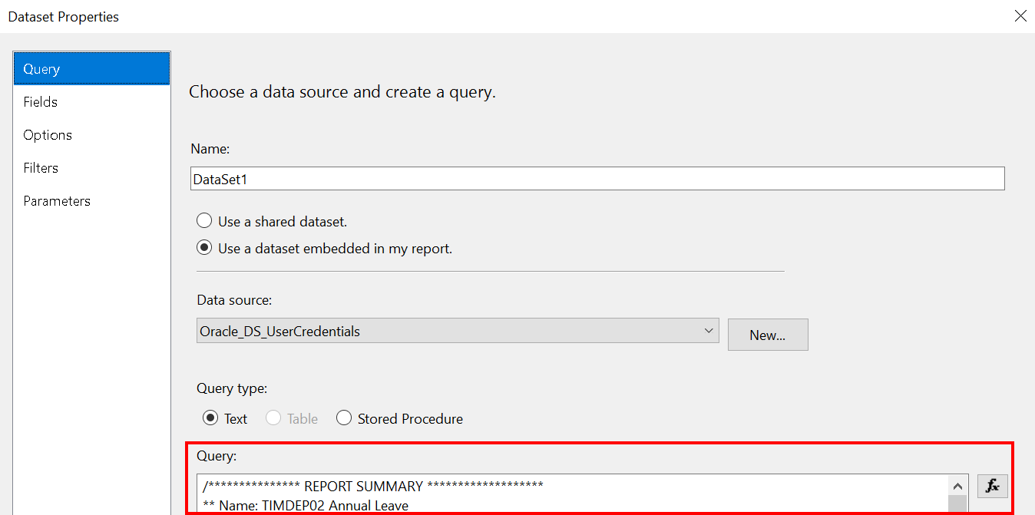

If the report has parameters, they will be listed in “WHERE” clauses within the SQL code, and they will always be in the format :ParameterName.

 | In Oracle SQL, the colon (:) is what prompts the report query to check for a user-defined value before executing the query. All parameter names must be preceded by a colon.
You can scroll down the Query pane to find the parameters within the SQL code, or you can copy the contents of the Query pane into a Notepad file and do a search for “:” to jump quickly to any parameters in the code:

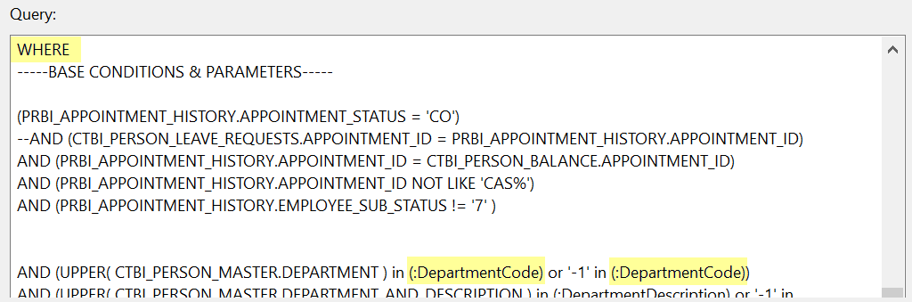

Within the Parameters folder
All the parameters present in the .RDL SQL query will also be present in the Parameters folder of the Report Data pane. Simply expand the folder to see the list of parameters:

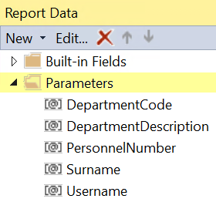

You can click into each parameter to view its properties. You can also access parameters within the section at the top of the Design pane – simply double-click the parameter you wish to view:

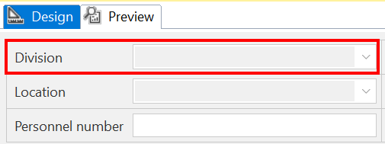

Double-clicking a parameter in either the Report Data pane or the Design pane will open the Report Parameter Properties window for that specific parameter.

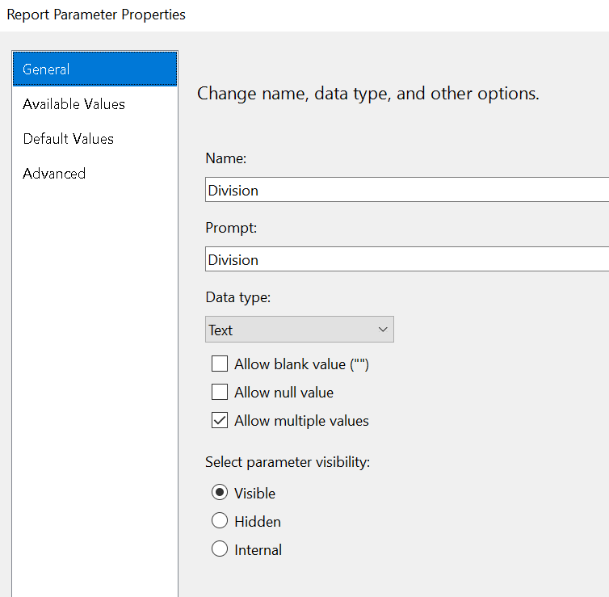

There are three main aspects to any parameter: General, Available Values, and Default Values. You can view these by clicking the tabs at the side of the Report Parameter Properties window.

- General: this tab defines the name of the parameter, the prompt a user sees when running the report, what type of data the parameter will accept, and whether or not the parameter should be visible to users.
- Available Values: this tab defines the list of values (LOV) which can be passed to a parameter, e.g. a list of department codes. If Available Values are defined, the parameter will only accept values from that list.
- Default Values: this tab defines what value(s) should automatically be passed to the parameter whenever a report is opened. Users can change the default value to something specific; the default is just present to save people time, so they don’t always have to select the most commonly-used values for a parameter.

Within the Parameters textbox
Most reports include a textbox above the Tablix in the Design pane which will display the selected parameters after the report is run.

Here’s an example of how that looks on a report which has just been run:
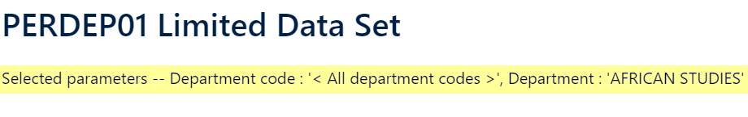

Within the .RDL file’s Design pane, the textbox looks like this:

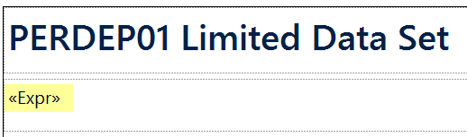

To view how the parameters are set up in the textbox, right-click it and select “Expression”:
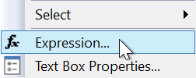

The Expression window will pop up. Within this window, you can see the VBA code which determines how each parameter is displayed within the textbox when the report is run.

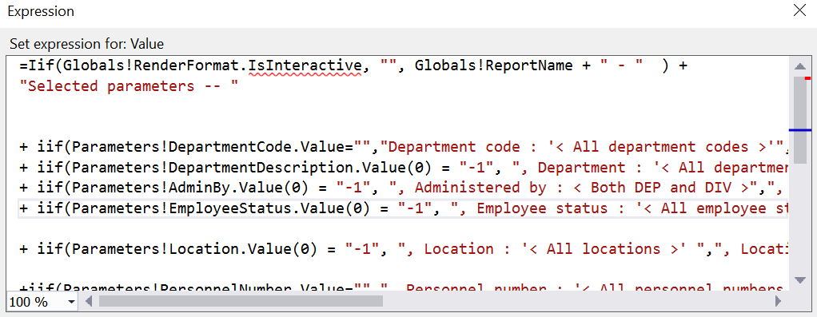

 | NB: Not all parameters are displayed in the textbox! “Username”, for instance, is never included here.

If a parameter is included in the textbox, it will appear as part of a “+” statement; e.g. this statement, which shows the DepartmentCode parameter for a report:

+ iif(Parameters!DepartmentCode.Value="","Department code : '< All department codes >'","Department code : '" + Parameters!DepartmentCode.Value + "' ")

What the code is saying
The VBA code here is just an IF-THEN-ELSE statement and can be understood as follows:

- IF the DepartmentCode parameter is blank (Value = “”), THEN the textbox should display the string “Department code: ‘< All department codes >’”.
- ELSE if the DepartmentCode parameter is not blank, the textbox should look at whatever values have been selected for the DepartmentCode parameter, and display the string “Department code: ‘[parameter value1, parameter value2,…]’”.

The majority of parameters in the textbox will be written in this format. See below for more guidance.

Creating a new parameter

Within the SQL code
To add a new parameter to the SQL code of the .RDL file, you will need to modify the appropriate “WHERE” clause within the code. Some reports contain only one “WHERE” clause, but complex reports may contain several, as conditions and parameters are applied to the query at different stages.

Decide where in the SQL you want to add the parameter, then add it to the “WHERE” clause in one of the following formats:

- For parameters which use a drop-down LOV…

Format: (VIEW.ITEM IN (:Parameter) OR ‘-1’ IN (:Parameter))
Example: (prbi_appointment_history.department_description IN (:Department) OR '-1' IN (:Department))

- For parameters which use a free-text field (single value)…

Format: (VIEW.ITEM = (:Parameter) OR (:Parameter) IS NULL)
Example: (prbi_hr_person_master.person_reference=(:PersonRef) OR (:PersonRef) IS NULL)

- For parameters which use a free-text field (multi-value), see the Appendix.

Once you’ve modified the SQL, be sure to save your changes to the .RDL file.

Within the Parameters folder
Go to the Parameters folder of the Report Data pane. Right-click and select “Add Parameter…”

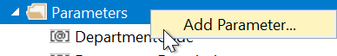

You can also create parameters within the section at the top of the Design pane. This is a little table which contains the parameters in rows and columns.

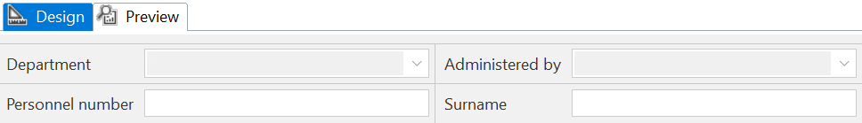

To add a parameter to this table, right-click an empty cell (like the one highlighted below) and select “Add Parameter…”.

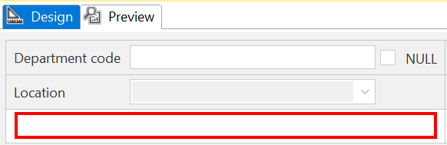

 | What if there aren’t any empty cells?  If you want to add a parameter to a report but there are no empty cells in the parameters table at the top of the Design pane, you can add a new row or column to the table. Simply right-click an existing row or column and select whether (and where) you would like to add your new row or column:  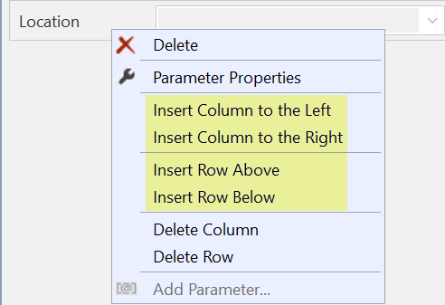  Once you’ve added the new row/column, you can right-click any of the empty cells and select “Add Parameter…” to create your new parameter.

After you click “Add Parameter…” in either the Report Data pane or the Design pane, the Report Parameter Properties window will open.

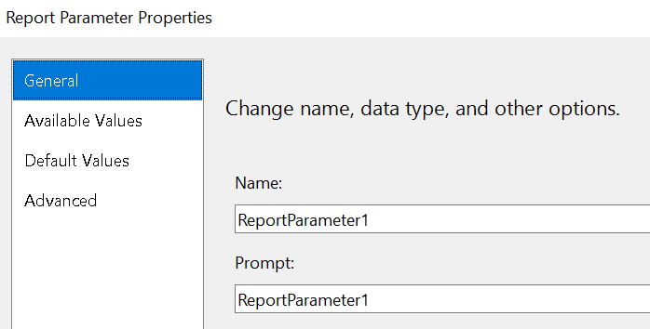

There are three main aspects which you must configure for every new parameter: General, Available Values, and Default Values.

General
The General properties of a parameter are displayed when you open the Report Parameter Properties window. They include:

Property | Values | Notes
Name | Name of the parameter | This must exactly match the name of the parameter within the report SQL code; e.g. if your parameter is called PersonRef within the SQL code, it must be called PersonRef within the properties screen.
Prompt | The user prompt | This can be whatever you like (although there are naming standards); e.g. the PersonRef parameter can have the prompt value of “Personnel number”.
Data type | Text, Boolean, Date/Time, Integer, Float | The only values used within HR Reporting .RDL files are Text (for alphanumeric fields) and Date/Time for date parameters.
Allow blank value (“”) | Ticked or unticked | This box should be ticked if the parameter is an optional free-text field which will pass a single value to the report query, e.g. Surname. This will allow report users to either specify a surname or to leave the Surname parameter blank before running a report.
Allow null value | Ticked or unticked | This box should be ticked if the parameter is an optional free-text field which will pass multiple values to the report query, e.g. Pay Code. This will allow report users to either specify a list of pay codes (‘135’,’247’,’630’) or to leave the Pay Code parameter blank before running a report.
Allow multiple values | Ticked or unticked | This box should be ticked if the parameter is an optional list of values from which a user can select one, several, or none, e.g. Department Code. This will allow users to specify which department codes they wish to run the report for. T
Visibility | Visible, Hidden, Internal | All parameters are Visible by default, except the Username parameter, which is Hidden.

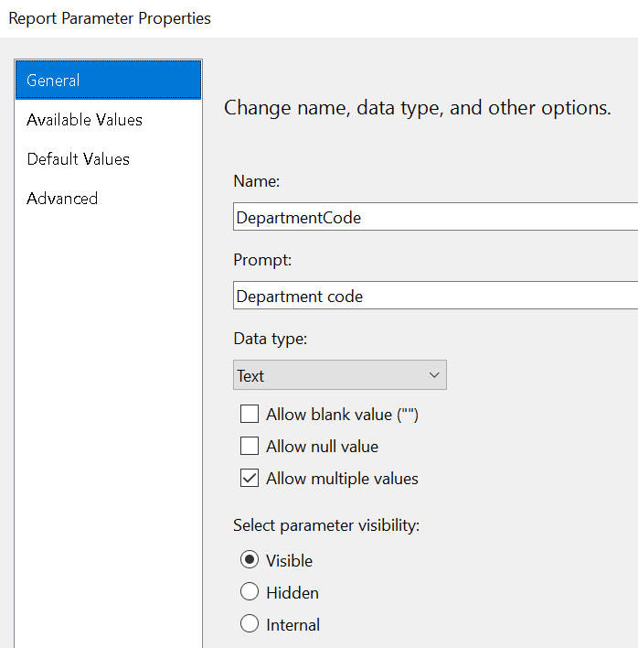

Naming standards for prompts
In order to maintain a consistent look and feel across the HR Reporting catalogue, parameter prompts must follow certain naming standards. These are outlined below.

- The prompt for a person reference must always be Personnel number.
- The word “description” is always omitted from prompt text; e.g. if the parameter is for “department description”, the prompt must be simply Department.
- Prompts of more than one word should only capitalise the first word; e.g. a prompt for the “employee status” value should be Employee status, not “Employee Status”.

Available Values
If your parameter is powered by a drop-down list of values (LOV), you will need to define the LOV you want the parameter to use. Go to the Available Values tab of the Report Parameter Properties window:

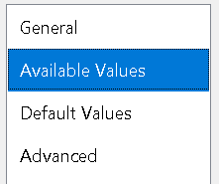

Here you can either select a shared dataset from which to derive the LOV, or define the values yourself.

If you’re using a shared dataset, select the option to “Get values from a query”, then complete the following fields:

Property | Values | Notes
Dataset | Name of the shared dataset | Select this from the drop-down list.
Value field | VALUE_FIELD | This must always be “VALUE_FIELD”.
Label field | LABEL_FIELD | This must always be “LABEL_FIELD”.

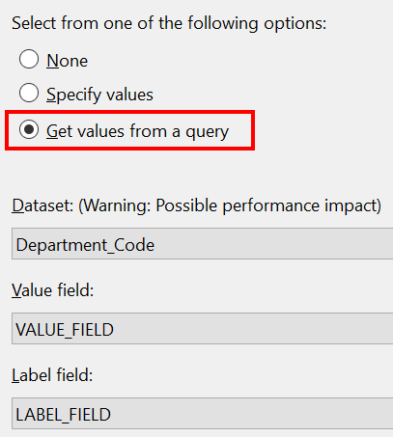

If you’re not using a shared dataset, you can create your own list of values by selecting “Specify values” and completing the following fields:

Property | Values | Example
Label | The value you want to be displayed in the drop-down list. | “Oncology”
Value | The value you want the parameter to pass to the report SQL code when the query is run. | “AA”

 | It’s okay if the “Label” and “Value” fields match each other, but it’s better for a report’s performance to pass shorter strings to the SQL query as parameter values.  In the example above, the department code (the value) “AA” is only two characters, while the department name (the label) “Oncology” is eight characters. Rather than passing “Oncology” as the parameter value, the report passes “AA” – which makes it run faster.

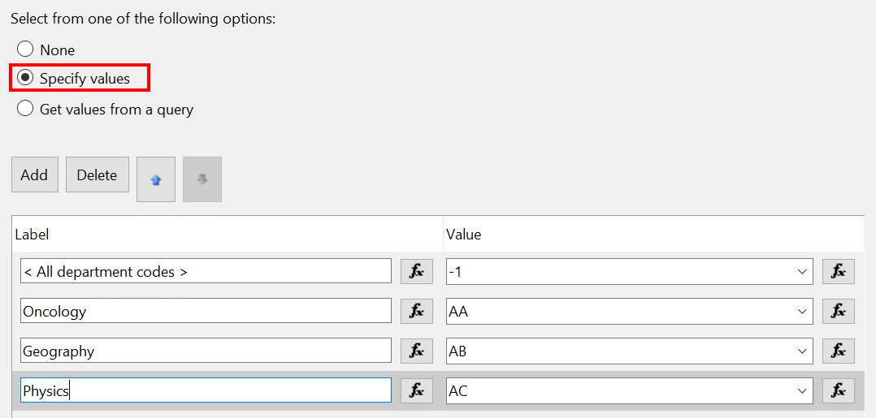

If you want to give users the option to select “All [parameter values]”, you will need to specify that in your LOV as follows:

- Label = < All [parameter values] >
- Value = -1

This is important: if you don’t specify a “-1” value in your LOV, users will not be able to run the report for all possible parameter values without selecting every value in the LOV individually!

Default Values
You can configure the default value(s) for your parameter by going to the Default Values tab of the Report Parameter Properties window:

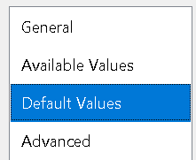

Here you can either select a dataset from which to derive the default value(s), or define the value(s) yourself.

 | Only the Username parameter uses a dataset to derive its default value. All other parameters either specify their own default values, or do not have default values.

If you’re setting the default value for the Username parameter, select the option to “Get values from a query”, then complete the following fields:

Property | Values | Notes
Dataset | CoreUser | Select this from the drop-down list.
Value field | CoreUser | This is the only field in the “CoreUser” dataset; it returns the report user’s SSO username.

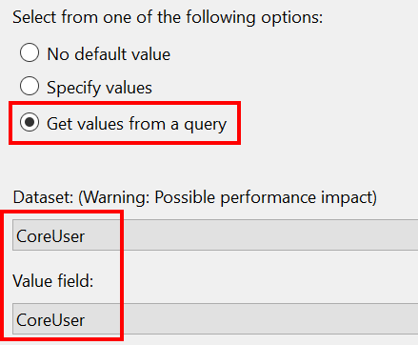

If you’re setting the default value for any other parameter, select “Specify values” and complete the following fields:

Property | Values | Notes
Value | This will nearly always be -1 | “-1” is the default value for nearly all drop-down LOV parameters. It tells the report query not to limit the results, but instead to return every possible value for the parameter, e.g. every possible department code.

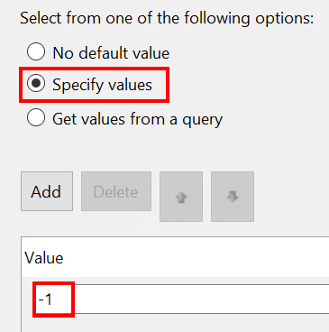

If you want to pass some other default value to the parameter, simply specify it in the Value field. You can add as many default values as you like: the purpose of a default value is to “pre-filter” a report for users so that they don’t have to select the most commonly-used values for parameters. A good example of this is the “Employee status” parameter, which uses several default values:

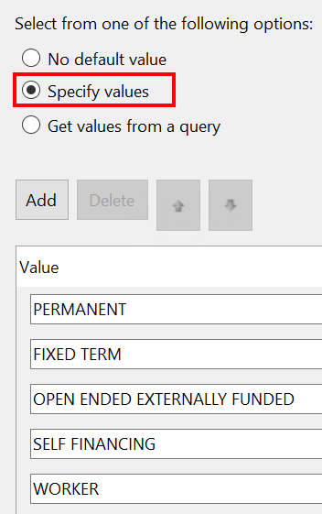

Free-text parameters, such as Personnel number and Surname, do not have default values; in those cases, you should simply select “No default value”.

Once you have set all your parameter’s properties, click OK to close the Report Parameter Properties window. Enter CTRL+S to save your changes to the .RDL file.

Within the Parameters textbox
After adding your new parameter to the SQL code and the Parameters folder, you have the option to add it to the Parameters textbox. This is not required unless you want the new parameter to appear at the top of the report after the report is run, as shown in this example:



If you want your new parameter to appear at the top of the report, you’ll need to edit the VBA expression within the textbox. The textbox sits between the .RDL title text and the report Tablix:



To edit it, right-click the box and select “Expression”:



The Expression window will pop up. Within this window, you can create the VBA code which determines how each parameter is displayed within the textbox when the report is run.

 | NB: It’s good practice to copy and paste the existing VBA code from another report with similar parameters; e.g. if you want to add a “Department Code” parameter, open the .RDL file for a report which already has a “Department Code” parameter and copy the VBA expression from that .RDL. You can modify the code as necessary for your own parameter(s) – this just saves you the trouble of writing the VBA from scratch.

The VBA expression
The VBA expression should always begin with the following code:

=Iif(Globals!RenderFormat.IsInteractive, "", Globals!ReportName + " - " ) +
"Selected parameters -- "

Once that code is in place, begin adding your parameters to the expression, following the guidance below.

 | NB: The parameters in the textbox expression should be listed in the same order as they appear in the parameters table at the top of the Design pane (reading from left to right). If your parameters table looks like this:  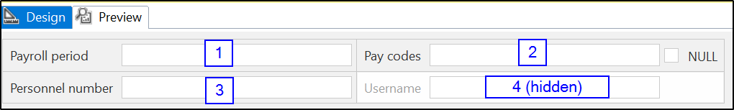  …then your VBA expression should list the parameters as follows:  - Payroll period  - Pay codes  - Personnel number  The Username parameter is hidden and is never included in the VBA expression.

LOV parameters
Parameters which use a drop-down list of values should be added to the VBA expression with an “IIF” statement. IIF statements in VBA are IF-THEN-ELSE statements:

+IIF(this condition is true), display this string, otherwise display this string

- Example: EmployeeStatus parameter
+ iif(Parameters!EmployeeStatus.Value(0) = "-1",
", Employee status : '< All employee statuses >'",
", Employee status : '" + Join(Parameters!EmployeeStatus.Label, ", ") + "' ")

Remember that back in the Report Parameter Properties window, you set the parameter value field to “VALUE_FIELD” and the label field to “LABEL_FIELD”. You can refer to these two fields within your VBA expression, so that the expression looks at the VALUE_FIELD to determine what LABEL should be displayed in the textbox; e.g. if the VALUE for EmployeeStatus is “4”, the LABEL displayed in the textbox will be “WORKER”.

Here’s that example again:

+ iif(Parameters!EmployeeStatus.Value(0) = "-1",
", Employee status : '< All employee statuses >'",
", Employee status : '" + Join(Parameters!EmployeeStatus.Label, ", ") + "' ")

You can modify this VBA to point to your own parameter by editing the parameter name within the formula to the name of the parameter you want to display. A list of available parameters is shown within the Expression window:

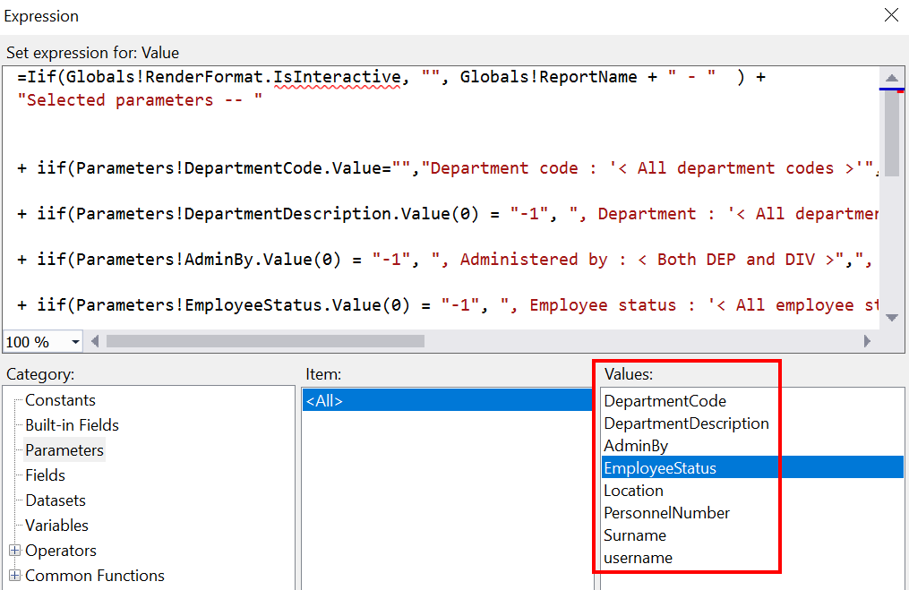

Free-text parameters (single- and multi-value)
Parameters which use a free-text field that accepts a single value, such as Personnel Number or Surname, should also be added to the VBA expression with an “IIF” statement, as shown above.

The only difference between the VBA for free-text parameters and the VBA for drop-down LOV parameters is as follows:

- For an LOV parameter, the IIF statement says if the parameter’s value is X, display the label Y:
+ iif(Parameters!EmployeeStatus.Value(0) = "-1",
", Employee status : '< All employee statuses >'",
", Employee status : '" + Join(Parameters!EmployeeStatus.Label, ", ") + "' ")

- For a free-text single-value parameter, the IIF statement says if the parameter’s value is X, display the value X:
+iif(Parameters!Surname.Value="",",
Surname : '< All surnames >'",
", Surname : '" + Parameters!Surname.Value + "' ")

- Likewise, for a free-text multi-value parameter, the IIF statement says if the parameter’s value is X, display the value X:
+ iif(Parameters!DepartmentCode.Value="",
"Department code : '< All department codes >'",
"Department code : '" + Parameters!DepartmentCode.Value + "' ")

Date parameters
Parameters which only accept Date/Time values, such as Start Date or End Date, do not require an IIF statement; they should just display whatever value was entered by the user. You can add a date parameter to the VBA expression with this format:

+Prompt text + FORMAT(DateParameter.Value, “dd/MM/yyyy”)

This code just sticks the parameter prompt text in front of whatever date the user selected for the parameter, and formats the date in dd/MM/yyyy style.

+"Period start date: '"+ FORMAT(Parameters!Period_start_date.Value,"dd/MM/yyyy") + "'"

Here’s an example from a completed report:

Once you’ve added your new parameter(s) to the Parameters textbox, be sure to enter CTRL+S to save your changes to the .RDL file.

Editing an existing parameter
If you need to edit a parameter which already exists in an .RDL file, you’ll need to perform the following steps in the order displayed below:

- Edit the parameter within the SQL code and test the amended code within SQL Developer to ensure your amended parameter is working as expected.
- If you’re happy with the updated SQL code, update the report query in the .RDL file with the new code.
- Once you’ve changed the report query in the .RDL, you should amend the Report Parameter Properties for the parameter you have changed. Be sure to check the General, Available Values, and Default Values tabs to record your changes in all the relevant fields.
- After updating the Report Parameter Properties, check the Parameters textbox to see if the VBA expression needs amending to reflect your changes.
- Enter CTRL+S to save your changes to the .RDL when you are finished.

Removing a parameter
If a parameter is no longer required, you can remove it from the .RDL file.

Within the SQL code
First, you’ll need to amend the SQL for the report query to remove all references to the parameter. Remember that parameters are located in WHERE clauses (and WITH clauses in the case of free-text multi-value parameters), so check these parts of the SQL code first.

Parameter values may be used in calculations or conditions elsewhere in the SQL, so don’t just look at the WHERE/WITH clauses! For complex reports, removing a parameter may require you to amend the SQL in multiple places.

Once you’ve updated the SQL and tested that it works correctly, save your changes to the .RDL file.

Within the Parameters folder
Now that the parameter is gone from the SQL, you need to remove it from the .RDL file. In the Report Data pane, go to the Parameters folder and select the parameter you want to remove. Right-click it and select “Delete”:

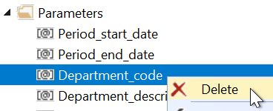

You can also remove parameters from the section at the top of the Design pane. Right-click the parameter you want to remove and select “Delete”:

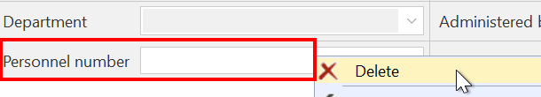

A warning message will pop up; click OK to confirm deletion:

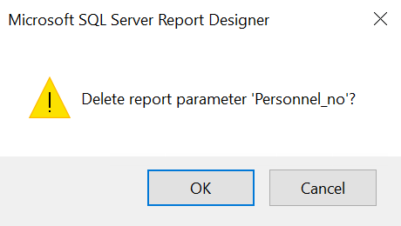

Enter CTRL+S to save your changes to the .RDL file.

Within the Parameters textbox
If the parameter you are removing is referenced in the Parameters textbox, you’ll need to delete any lines of VBA code which refer to it. Right-click the textbox and select “Expression”:



The Expression window will open. Select the line of VBA code you want to delete and hit “Delete” on your keyboard.

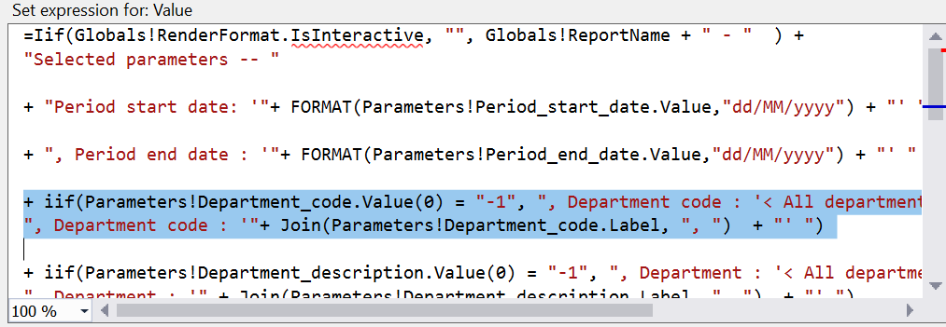

Click OK to exit the Expression window and enter CTRL+S to save your changes to the .RDL file.

Appendix: Free-text multi-value parameters
Many reports have free-text parameters which will accept multiple values in a comma-separated list, e.g. a list of pay codes. This enables report users to type in a list of the exact codes they want to see in the report, without having to scroll through a long drop-down LOV to select each code.

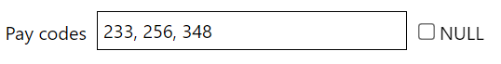

The SQL which supports a free-text multi-value parameter is a little complicated, so here’s a worked example for the pay code parameter shown above.

The WITH clause
Free-text multi-value parameters rely on something called a “WITH” clause, which is a bit of SQL which defines a temporary dataset whose output is available to be referenced in subsequent queries.

At the top of the appropriate SELECT statement in your report, add a WITH clause which includes your parameter. The format should be as follows:

(WITH temporary_dataset AS (SELECT :Parameter AS temporary_item FROM DUAL)

SELECT
…rest of SELECT statement… )

Example:
(WITH paycodetext AS (SELECT :PayCode AS paycode_text FROM DUAL)

SELECT
PABI_PAY_HISTORY.PAYROLL_PERIOD as PAYROLL_PERIOD… )

The WITH clause here has created a temporary view called paycodetext which contains a temporary item called paycode_text. The values available for the paycodetext.paycode_text item are defined by whatever the report user enters in the :PayCode parameter free-text field.

The WHERE clause
Now that you’ve added your WITH clause, you can add the parameter to the appropriate WHERE clause in your report.

 | NB: You’ll have to use the WHERE clause which belongs to the SELECT statement to which you added the WITH clause. Complex reports contain multiple SELECT statements and multiple WHERE clauses, so be sure to modify the appropriate WHERE clause!

In the WHERE clause, you’re going to refer back to the WITH clause you just created, using the following format:
WHERE
(VIEW.ITEM IN
(SELECT
UPPER(regexp_substr(temporary_dataset.temporary_item, '[^, ]+', 1,LEVEL))
FROM temporary_dataset
CONNECT BY INSTR(temporary_dataset.temporary_item,',', 1, LEVEL - 1) > 0)
OR (:Parameter) IS NULL)

Example:

WHERE
(PABI_PAY_HISTORY.PAY_CODE IN
(SELECT
UPPER(regexp_substr(paycodetext.paycode_text, '[^, ]+', 1,LEVEL))
FROM paycodetext
CONNECT BY instr(paycodetext.paycode_text, ',', 1, LEVEL - 1) > 0)
OR (:PayCode) IS NULL)

This bit of code tells the report to return records where the PABI_PAY_HISTORY.PAY_CODE is included in the temporary paycodetext dataset. It also tells the report how to “read” the paycodetext dataset, which is just a comma-separated list. The regexp_substr() and instr() functions are essentially telling the report to create a new row in paycodetext every time it encounters a comma, so that this list:



…gets transformed into this table:

paycodetext
233
256
348

The report should return any records where the PABI_PAY_HISTORY.PAY_CODE is included in this temporary table.

The NULL option
If the user doesn’t want to specify any pay codes, they need to tick the “NULL” box next to the parameter.

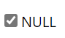

This tells the report to ignore the parameter and skip all the code described above.
 | NB: For free-text multi-value parameters, users must either enter some values or select “NULL”; they cannot leave the field blank. If they do leave the field blank, the report will try create a temporary dataset that contains zero rows, and to use that as the basis for the parameter – which won’t work.

